Newcastle Virtual School Annual Report 2019/20.

Introduction.
This report covers the academic year 2019/20 which was interrupted by the impact of the Covid 19 pandemic placing unforeseen challenges upon the Virtual School.
Split into two sections, the report seeks to present the two halves of the year that reflect the two very different sets of challenges.
- Prior to 20th March 2020, the profile of the virtual school and progress up to this date
- Post 20th March 2020, responses to Covid 19 the measures taken to ensure CiC continued to receive the best education possible.
It is difficult to compare 2019/20 with other previous years due to events and subsequent disrupted data collection. All data used in this report unless stated otherwise has been provided by the LA’s Capita One data base. As Virtual School Headteacher I hope that this report sets out the impact of the measures taken.
Karl Harms, Virtual School Headteacher. January 2021

Contents
Section One: Pre 20th March 2020.

Staffing Structure 2
Profile of Virtual School 2
Attendance and Exclusion 4

Section Two: Post 20th March.

Covid Responses
- Safe and well 5
- Laptops 5
- Covid PEPs 5
- Lockdown Competitions 7
- Attendance and Return to School 8

2020 Progress and Achievement 8
Pupil Premium Plus 10
Priorities and Developments 20/21 10
Examples of Good Practice. 11

Staffing Structure
Virtual School Headteacher.

Senior Education Achievement Worker.

7 Education Achievement Workers
1.6 Business Support

The Education Achievement Workers (EAW) have a key role in ensuring that all CiC have an up to date Personal Education Plan (PEP) and that it continues to meet their academic needs. They work with a range of professionals including social workers, designated teachers, carers, and young people
Children in Care (CIC) are more likely to have Special Educational Needs which adds to their vulnerability. They are susceptible to school moves and there may have been missed opportunities to apply for an EHCP assessment of needs or identify individual strengths. The Virtual School works closely with the SENAPR service and commissions LA educational psychologists to give guidance and advice related to individual educational needs to assist in maintaining or identifying school places. The EAW’s work closely with Access and Inclusion staff to ensure that school placements are smoothly actioned, and attendance maintained.
Virtual School Profile
Since last year the Virtual School has increased by 68 students of which 11 were of school age. The percentage educated outside of Newcastle remained the same at 37%. The number of young people spending more than a year in care rose by 63. This figure is in line with the with the increase in children registered with the Virtual school.
Profile of Virtual School: 20/03/209

663 CiC were registered with the Virtual School.
This represents 1% of Newcastle children
428 were of statutory school age.
37% were educated outside Newcastle.
513 had been in care for more than a year.
Capita Data Base

Current school sector for students NCY 0-11

There are 428 Current CiC students NCY 0 - 11

Sector | No School | Newcastle School | Non-Newcastle School | Total
Primary |  | 126 | 55 | 181
Secondary |  | 83 | 63 | 146
Special |  | 33 | 30 | 63
Other |  | 20 | 11 | 31
No School | 7 |  |  | 7
Total | 7 | 262 | 159 | 428

Special Education Needs
Number of CiC SEN students

Gender | School Support | EHCP | No identified SEN
Female | 57 | 25 | 236
Male | 71 | 54 | 220
Total | 128 | 79 | 456

There are 79 current CiC students who have an EHCP this is 11.9% of current CiC students as compared to 12.5% in the previous year.

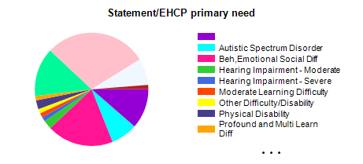
The most common primary need for students is Social, Emotional and Mental Health. This applies to 53 students or 8% of the Virtual School.

Attendance and Exclusion
This year’s attendance is comparable with the same date on previous years. The CiC attendance for the whole year in Newcastle Schools was 82% this reduction was a direct result of Covid-19.
Attendance outside of Newcastle schools stood at 95% on 23rd March and had dropped to 93% by the years end.

There were no permanent exclusions in 2019/20, this is a reduction from four in the previous academic year, which in turn may impact upon the rates of fixed term exclusion.
In the academic year up to 20th March 2019 there were 78 incidents of fixed term exclusion. The following year up to 20th March this figure rose to 111 incidents.
After 23rd March 2020 there were only 3 incidents of fixed term exclusion, totalling 9 days, all involving the same student.
The inconsistencies of data and provision illustrates the difficulty in making year by year comparisons during the Covid 19 disruptions.

Covid Responses.
Safe and Well
Following from lockdown on the 20/03/2020, the Virtual School’s first response was to contact all Foster Carers by telephone to ensure the safeguarding of children. The decision was made to approach Carers so as not to overburden schools with excess communication. The following Red, Amber, Green ratings were applied to recognise the initial importance of safety over education.
Not following social distancing.  Not engaging in educational activity. | Following social distancing.  Not engaging in educational activity. | Following social distancing.  Engaged in educational activity.

Close working and shared practise with Children Social Care (CSC) ensured the safety of all children within the Virtual School.
As a result, the Virtual School was able to report on all children, ensure they had access to online learning or attended a school site. Additional Pupil Premium Plus (PPP) were made to support any additional costs of home learning. All PEPS were revisited due to the significant change in circumstances.

Laptop Scheme
From 20/04/2020 April the Virtual School carried out additional telephone surveys for the government laptop scheme to find out if there was a suitable digital device and access to the internet at home. Non-contacts were followed up and most carers were contacted on a first trawl. The small number of remaining non-contacts were completed for a subsequent submission.
Category | Number of pupils
Form successfully completed | 517
Contact made, but form not completed* | 3
Unable to make contact** | 33
Total*** | 553
The Virtual school took on the additional task of co-ordinating lap top applications for post 16 care leavers

Covid PEPs
In response to the ending of face-to-face meetings, uncertain staff capacity in schools and within the Virtual School, and the requirement to review all cases due to a change of circumstances, PEP (personal education plan) documentation had been revised and rewritten. This information was shared with headteachers and social workers through single points of contact in Education and Children’s Social Care.
The Covid PEP has been the cornerstone of Virtual School adaptations.
It has given us:
- a sharper document to focus upon current need
- agreement confirmation of a student attending school or otherwise
- ability to support home education, if required
- targeting of pupil premium plus (PPP) funding to the individual student’s needs
- retention of block payments to schools, thereby allowing us more flexibility in building bespoke support over the coming months
- flexibility to review within the CiC review cycle if the need arises.
An Example of a Completed Covid PEP
Is the young person attending school?
If not, how often and by what method, is the young person being contacted during school time?
No
School have been contacting Sue, as have Ami and Pat. (PEP completed through Care Team Meeting and information from telephone conversations.)

Are the care team in agreement with the education arrangements?
Is access to a school place required?
Yes, discussed and agreed with Care Team Members.

Plan is for Rocco to attend Total Tuition (TT) via his EHCP. Agreement needs to be sought from SEND, Northumberland and Newcastle, and TT to gain independent special school status, and Procurement to be able to place the school on the NE12 framework.

What are the current learning objectives for the young person?
Engagement
Rocco to engage in any education that feels right for him at the time.

Emotional well-being
Rocco to feel safe and secure in all areas of life through working with NSPCC.

Young Person’s Views
Rocco finds it difficult to think of education away from school, so Sue is not pushing him to sit down and complete work, more slipping educational things into daily life skills.

Is there a need for additional funding through PPP to support home schooling arrangements?
If so, please complete the remaining sections.

Please give a breakdown of the additional resources you wish to provide while the young person is not attending school, and describe the impact that you feel these resources will have on their learning:

Total Tuition as an Alternative Provision, five half days a week

Learning Objectives
1. To read books and texts that are appropriate to his reading age/level

2. To recall times tables, comfortably, up to twelve times tables

3. To plan and write a range of texts across various genres

Resources Required | Cost
1 Laptop  2. Text/reading books for relevant subjects  3. Virtual tutor (if required) | 1. Government scheme applied for  2.  3. TBC Total tuition
Intended Impact on learning
1. Higher engagement with a wide variety of e-learning resources

2. Increased knowledge of a range of texts to support both reading and writing

3. If required, online support via a virtual tutor

Decision to award and why
Agreed by Karl Harms to award £1500 to Welbeck for Total Tuition.

Lockdown Competitions
“The best advice I can give you for general life is not to expect too much from anyone because you will only be let down and disappointed. We have gone through so much in life and I remember when I was in your position, I was desperate from someone to love me and be a father or mother figure and I looked up to people but people come and go. I also expected everyone to treat me the same, but you aren’t the same, because we had to go through so much at such a young age, we grow up a lot quicker than everyone else. Don’t change to fit in just be you and whoever sticks around is worth your time. You have people in your life, that you haven’t met yet, that will fight for you and love you unconditionally. So just keep going and take each day as it comes until you feel strong enough to fight back and leave.”
BG aged 15

The Virtual School started its weekly competitions which have resulted in some examples of very profound writing. The children have been rewarded with INTU shopping vouchers through the post that they can now spend. Some of this work was put into a brochure on 20/05/2020 and a video featuring student voiceovers of their work was compiled in August 2020.
Attendance and Return to school.
There was a variety of reasons given for children not attending a school site, household members who were shielding, not wishing to be recognised as being in care, being different from peers and general uncertainty. During the period of school closure 36% of children attended school for some time each week.
Numbers increased following the wider reopening of schools and recovered to 82% attendance by the end of the summer term. This is short of expectations but must be taken into context against the year.
Previous results compared to national predicted outcomes by National Consortium of Examination Results. |  | 2017  NCC  Results | 2018  NCC  Results | 2019  NCC  Results | 2019  National results | 2020  National predicted outcome
Key Stage 1 | KS1 Reading EXS + | 41.7% | 50% | 66.7% | 52% | 49.0%
 | KS1 Writing EXS + | 25% | 62.5% | 66.7% | 42% | 44.0%
 | KS1 Maths EXS + | 41.7% | 75% | 66.7% | 49% | 46.0%
 | KS1 RWM EXS | 25.0% | 37.5% | 66.7% | 37% | 39.0%
Key Stage 2 | RWM Expected Standard | 27.8% | 33% | 57.1% | 37% | 42.0%
 | Reading Expected Standard | 38.9% | 52% | 61.9% | 49% | 54.0%
 | Writing Expected Standard | 61.1% | 52% | 71.4% | 51% | 50.0%
 | Maths Expected Standard | 44.4% | 48% | 66.7% | 51% | 55.0%
 | Reading Progress | -0.4 | -0.1 | +2.8 | -0.2 | -1.20
 | Maths Progress | -0.2 | -0.2 | +1.2 | -1.0 | -0.80
 | Writing Progress | +1.6 | -0.7 | +2.4 | -0.9 | -0.59
Progress and Achievement
With no testing taking place it is difficult to measure the progress of our students. Previous results for primary aged students compared very against predicted national outcomes. This suggests that the cohort will continue to perform well.

Because of the highly unusual events this year, the DfE and Ofsted have not requested any data and have asked the same of LAs. All regional LAs have agreed not to ask schools for results.
What should be considered, is that some students might have been awarded a borderline “pass” or qualifying grade that they may not have achieved under normal circumstances. They will need to be watched as they may struggle at their new stage of learning. To gain an insight of how our students have achieved a local survey was conducted by the Virtual School.

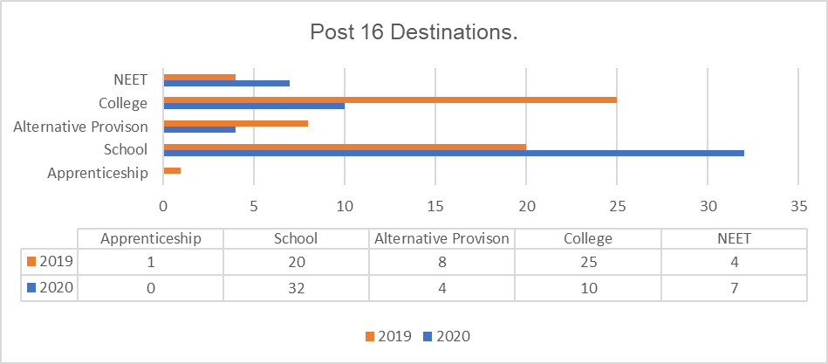
There has been an interesting shift in post 16 destinations for the current year 12 cohort. There has been a marked increase in children staying on at school and a drop in college places. This may be an impact of staying in a familiar place due to impact of lockdown or that students achieved the grades that enabled them to stay on in sixth form. Fifty five percent of learners passed five or more GCSEs, twenty seven percent achieved a good grade in Maths and English. There is also a strong element of twelve and half percent who gained more than five GCSEs including Maths and English.

Pupil Premium Plus
Pupil Premium Plus payments were withheld at the start of the summer term to allow for assessment of need related to Covid restrictions. As a result, thirty-seven applications were made for funding over the £500 termly allowance. A total of £3,661.03 was made in additional Covid related payments. The remaining PPP was distributed to schools on 24th August 2020.
Term | Amount paid per child | Ncle LA Schools | Academies/Others | G'head LA Schools | N'land LA Schools | Paid out
Autumn | 500.00 | 45,500.00 | 122,900.00 | 6,000.00 | 5,500.00 | 179,900.00
Spring | 700.00 | 68,900.00 | 187,950.00 | 7,700.00 | 7,700.00 | 272,250.00
Summer | 500.00 | 50,799.03 | 115,923.64 | 5,000.00 | 4,000.00 | 175,722.67
Total |  | 165,199.03 | 426,773.64 | 18,700.00 | 17,200.00 | 627,872.67
Payments made 2019/20

Development and Priorities
In July 2020 an internal LA review of the Virtual School was initiated This work will be completed by November 2020 informing future developments and priorities within the Virtual School.
Ares for specific consideration are:
- Introduction of an electronic PEP.
- Pupil Premium Plus policy.
- Interagency working.
- Identification of vulnerable groups with the Virtual School.
- Inclusion and alternative provision.

Examples of good practice

