Creating an account
- To create an account, so you can apply for a permit, you are first taken to this screen
- As this is your first time using the system, please click on Customer Register / Sign In. After you have created an account, each time you come back to this page you will then use Sign in.
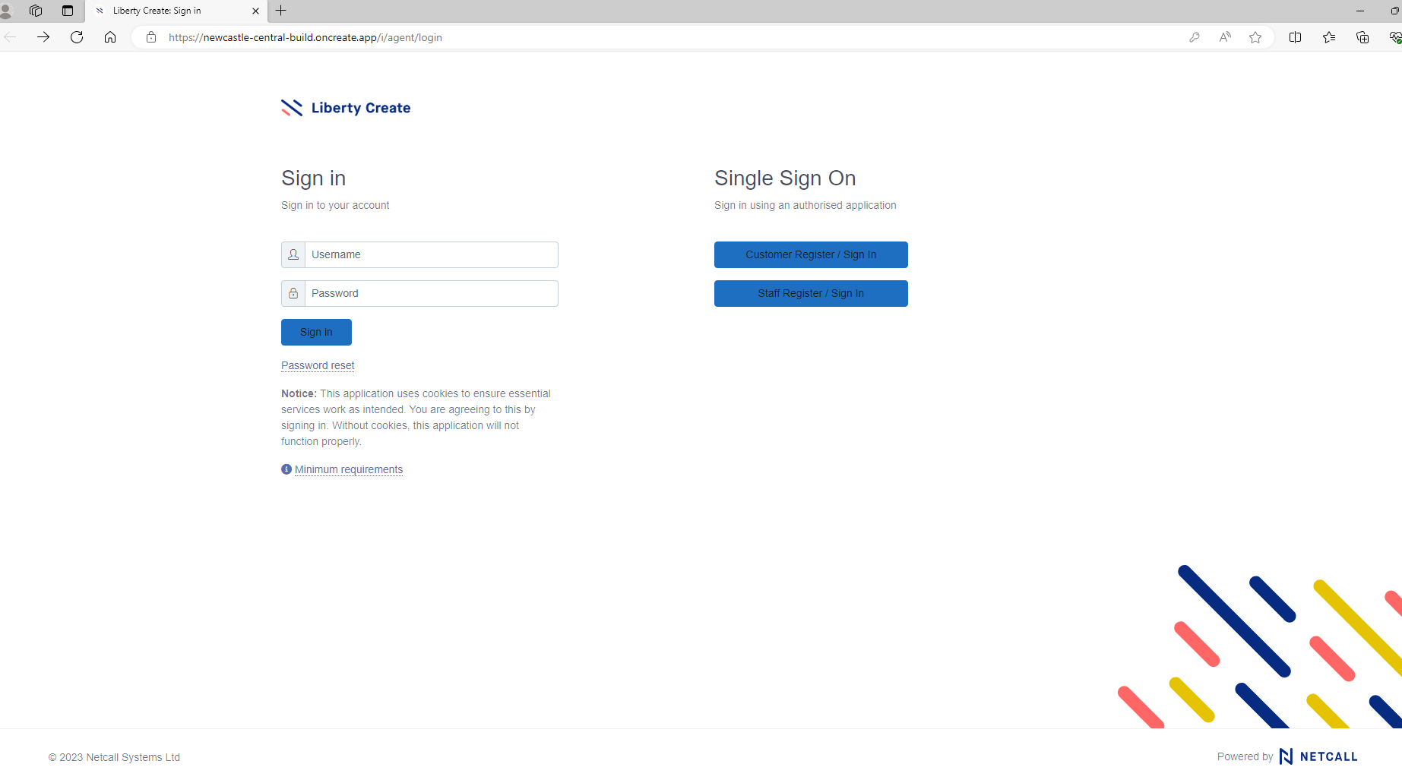
- Once you click the Customer Register / Sign In button, you will be taken to the below screen.

- Please see the “Don’t have an account? Sign up now” below the sign in button and click “sign up now” which will take you to the below page.

- Please enter your email address into the top box and click on Send verification code. You will then be sent an email with details of the verification code that you will need for the screen below.
- Use the verification code from the email you have received in the second box and click on Verify code.

- Once the code has been verified you will be asked to enter details of your first name and family name and to create a password for your account.
- The password must be between 8 and 64 characters and must have at least 3 of the following:
- a lowercase letter;
- an uppercase letter;
- a digit;
- a symbol.
- Click on the blue button marked Create. You will then see the screen below, that confirms your information is being processed.

- You may be taken to the multi-dactor authentication screen as above. Please choose the country code from the drop down enter your mobile number in the bottom box and click the “send code” button. One you receive the code via text message on your mobile, please enter this code

- Once your account has been created, you will be taken to the home page, where you have options to make an application, check the progress on any existing applications or to manage your account.

