Submitting an application – Supplementary Scratchcards
- After creating an account (if you haven’t done this, please see the guide found here) you can log in to your account by clicking “Customer Register/Sign in” button
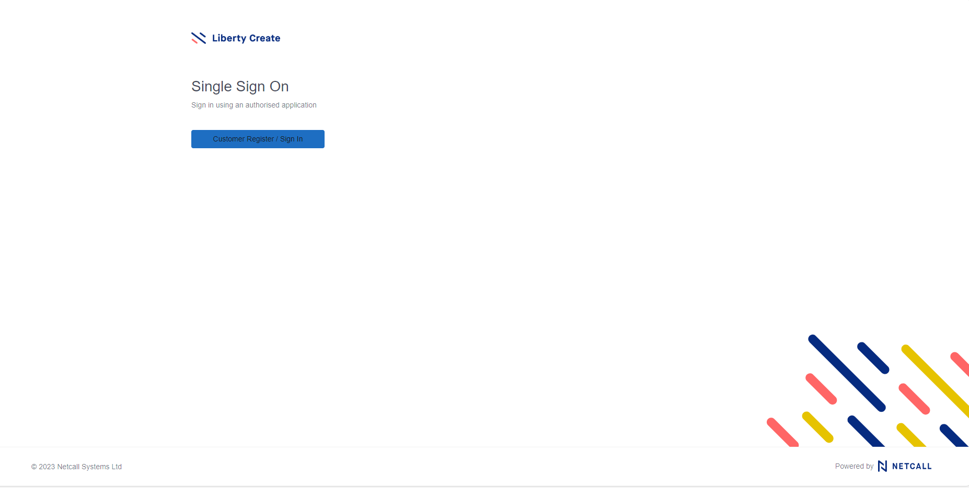
- Enter the email address and password that was used to create your account and click “sign in”
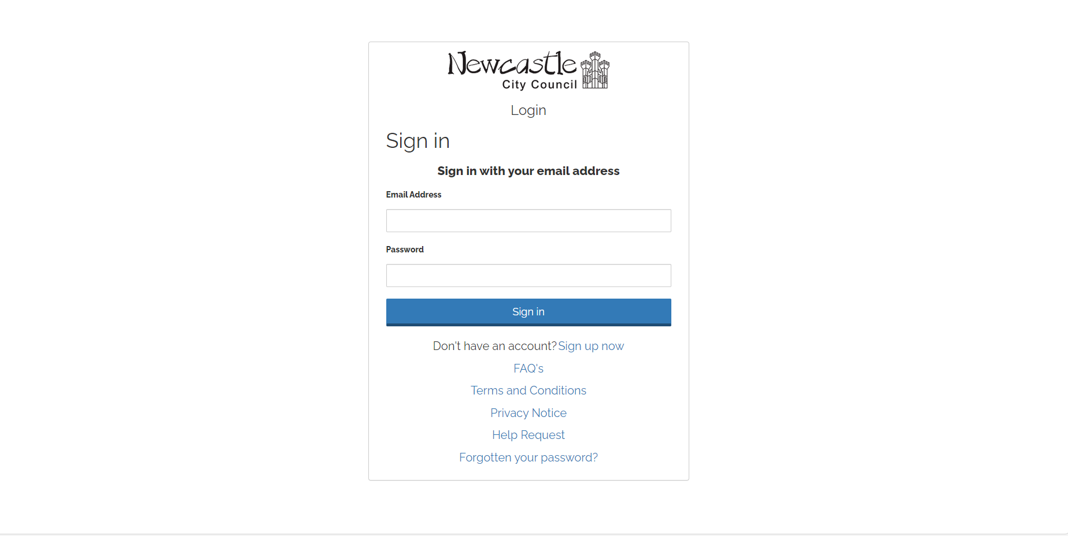

- After logging in, you will come to the Citizen Hub home page, as shown below
- To submit a Supplementary Scratchcard Application, click “Make a New Application” heading in the top left as per above.

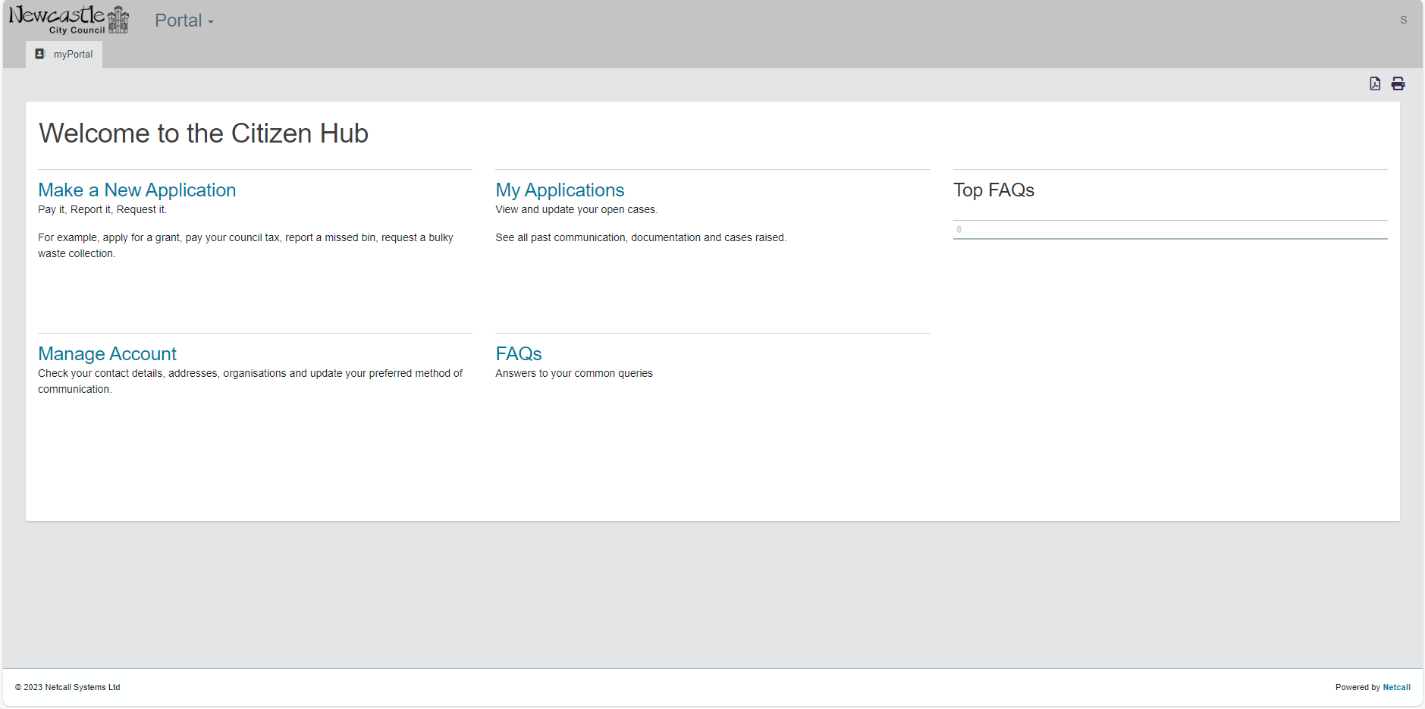
- You will then be taken to a new page.
- From the list on the right-hand side, click “Parking Services – Supplementary Scratchcards”

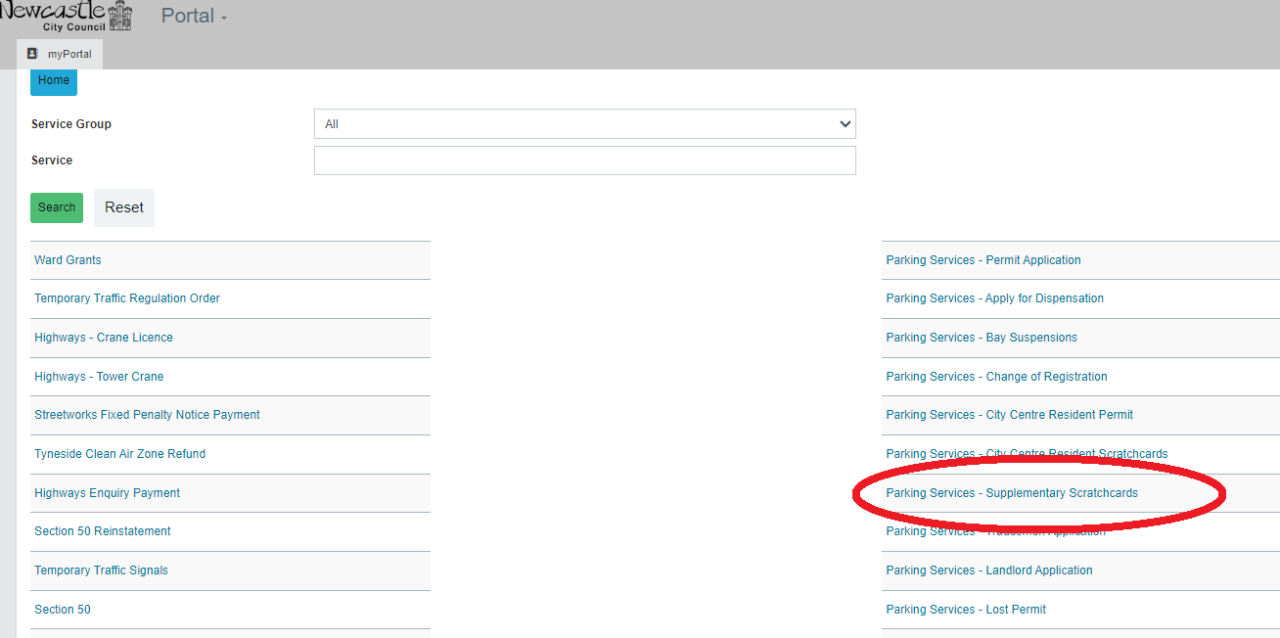

- You will then be taken to the below screen where there is some important information that needs to be read on Newcastle City Council’s Privacy Notice (accessed via the circled link), prior to ticking the box.
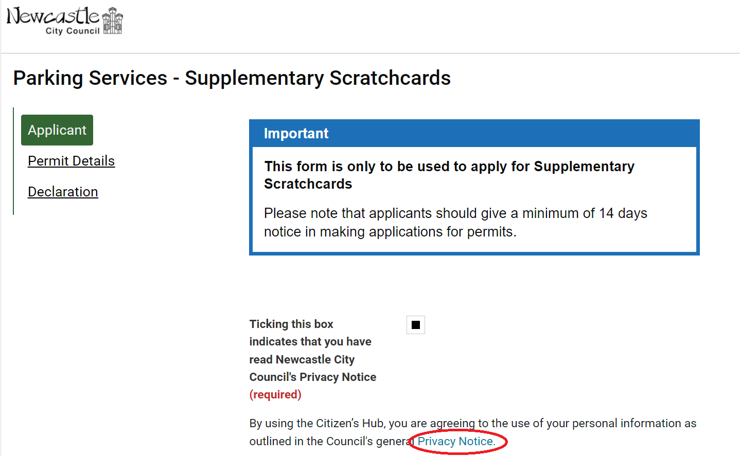
- Proceed to complete the rest of the form, completing every field for your personal data and address, then click the “Continue” button
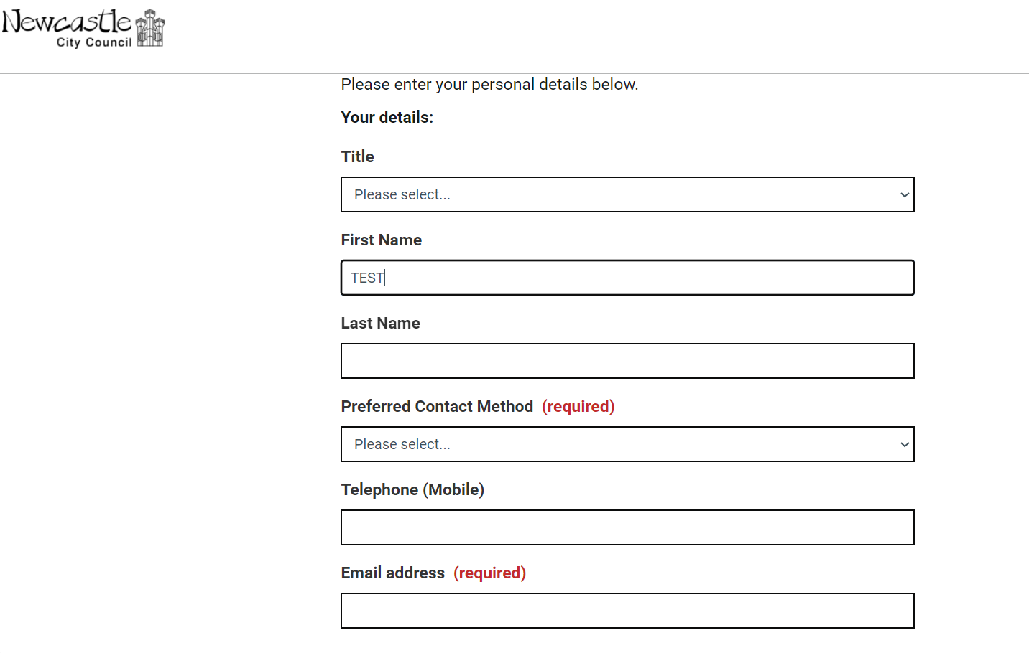

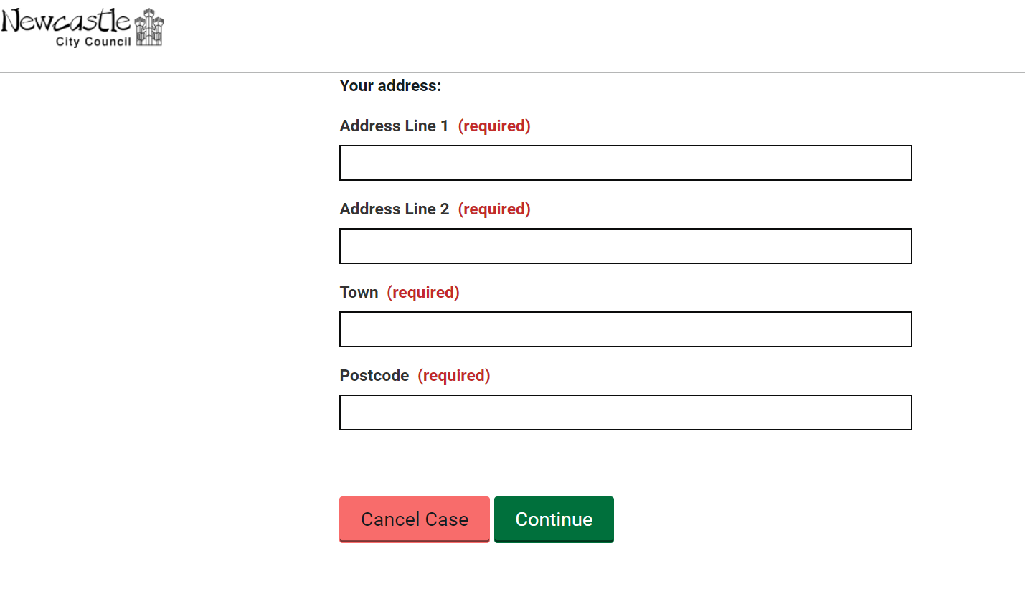
- Following this, select “Resident” from the drop down menu for the type of Scratchcards you want to apply for, and complete the two further drop down menus for the number of both full and half day scratchcards you would like (select 0 if none for a type)
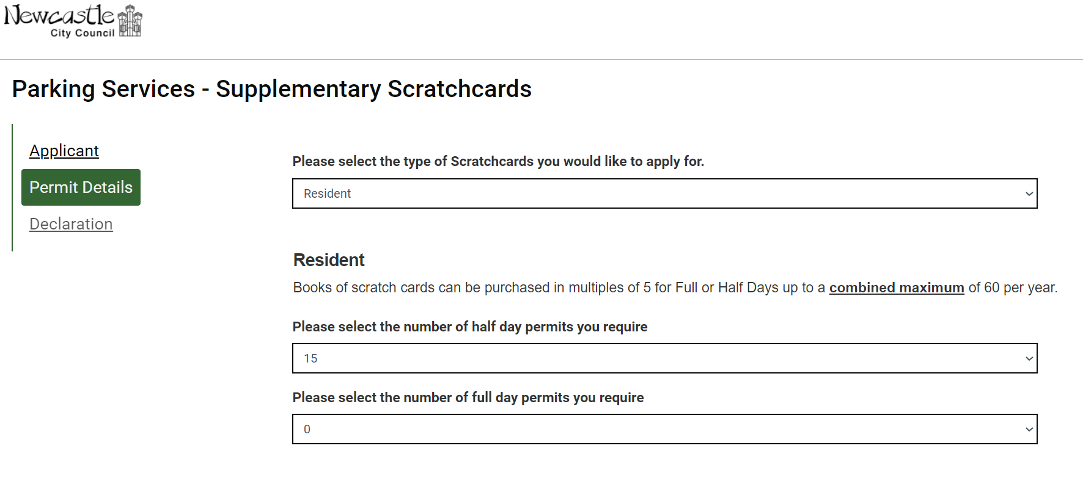

- You will be asked if you a current Resident Permit Holder at the address. If you are and select yes, you can click the Continue button.
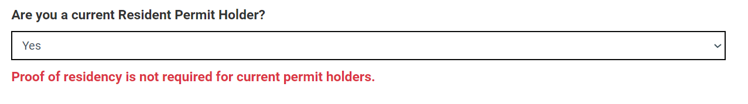
- If you do not currently hold a valid permit at the address, you will need to submit proof of address via the grey box.
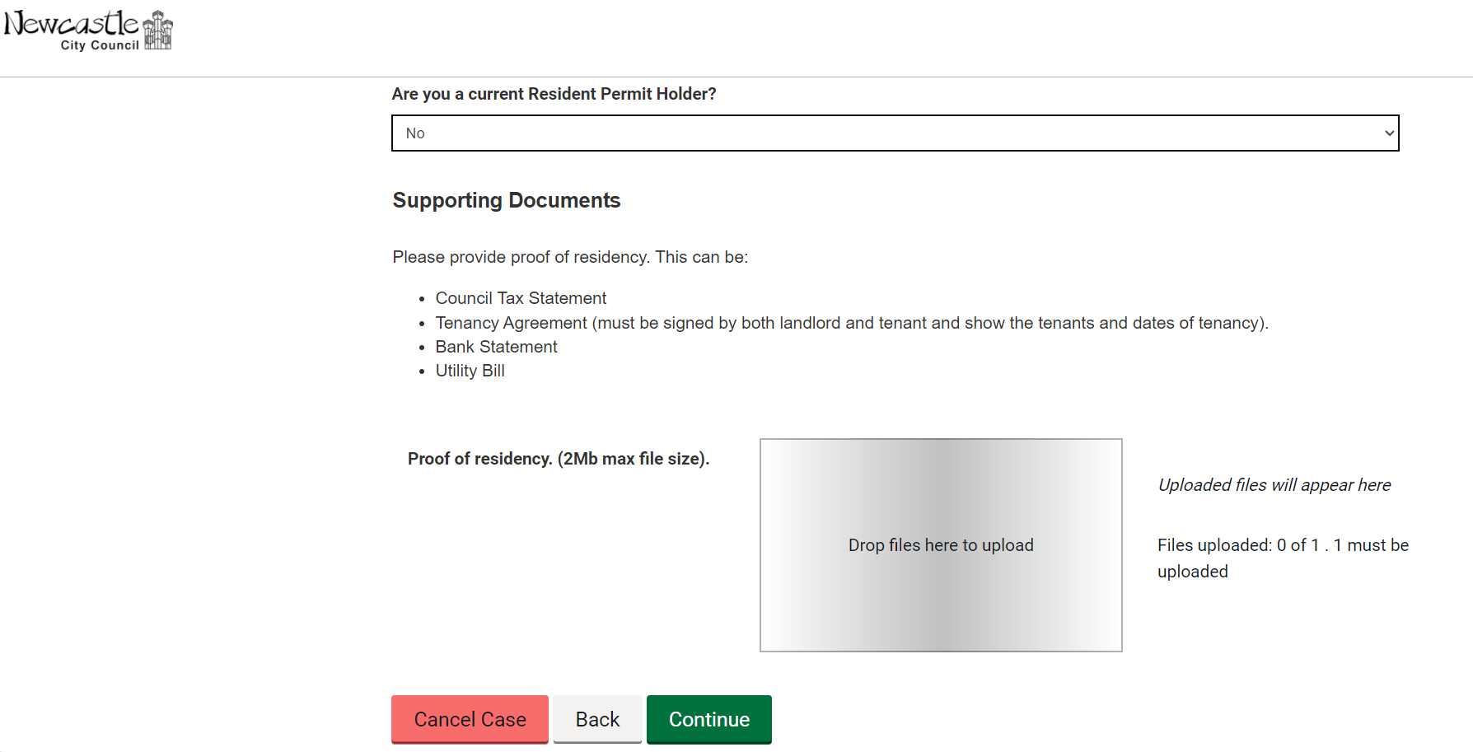
- Once your file is uploaded, click the “Continue” button underneath
- You will then be taken to the final section of the Application Form.

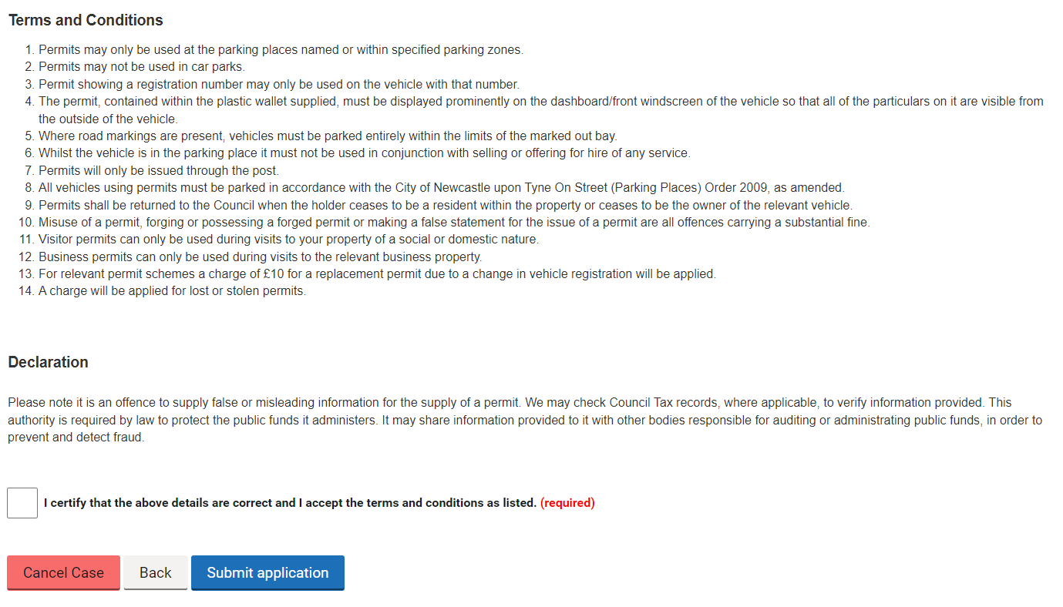
- Please read the terms and conditions and the declaration, once these have been read and understood, if you agree to accept the terms and conditions, click the box
- You can then click the “Submit application” button

