**Self-isolation**

Anyone with COVID-19 symptoms or a positive test result should stay at home and self-isolate immediately.

If you have symptoms of COVID-19, you should arrange to have a **PCR test** as soon as possible.

**This still applies even if you have received one or more doses of COVID-19 vaccine or had Covid more than 90 days ago.**

If you live in the same household as someone with COVID-19, or if you have been informed that you are a close contact of a person who has had a positive test result for COVID-19, **you must stay at home and self-isolate and book a PCR test.**

The most important symptoms of COVID-19 are recent onset of:

* **a new continuous cough**
* **a high temperature**
* **a loss of, or change in, your normal sense of taste or smell**

For most people, COVID-19 will be a mild illness. However, if you have any of the symptoms above, even if your symptoms are mild, stay at home and arrange to have a test.

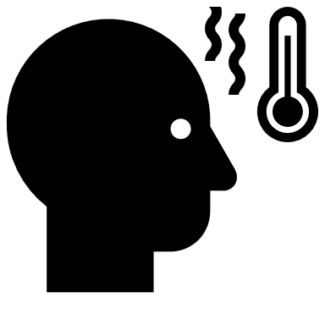

**Symptoms**



**Isolation period**

Your isolation period starts immediately from when your symptoms started, or if you do not have any symptoms, from when your test was taken.

Your isolation period includes the day your symptoms started, or the day your test was taken, and the next 10 full days as this is when you will be infectious and can spread it to others.

If you are a **close contact** of someone who has COVID-19 and you are fully vaccinated, or aged under 18 years 6 months, you are not required to self-isolate, but you are advised to isolate until you receive a negative PCR test result.

Fully vaccinated means that you have been vaccinated with an MHRA approved COVID-19 vaccine in the UK, **and at least 14 days have passed since you received the recommended doses** **of that vaccine.**

If you are a close contact but do not have to isolate, you should minimise all social contact and avoid contact with anyone at increased risk due to their age or health for the full period that the isolation would have lasted in order to protect them. If you develop symptoms you should isolate and take another PCR test result.



**When not to isolate**



**Food & Essentials** – Check you have enough food and essential items. Shop online or ask friends and family for help.



**Money -** Make a plan for accessing your money and paying your bills. If you are struggling financially, you may be eligible for Crisis Support.



**Work** – Ask your employer about sick pay. If you need an isolation note visit: **https://111.nhs.uk/isolation-note/**

**Children -** Contact the school to arrange for free school meals to be delivered to the home, if you are entitled, and ask about schoolwork.



**Children -** Contact the school to arrange for free school meals to be delivered to the home, if you are entitled, and ask about schoolwork.

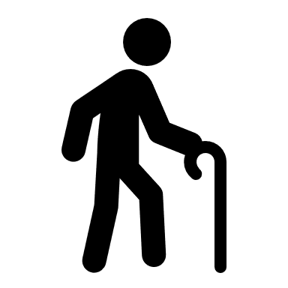

**Dependants –** Ask family and friends to provide care for dependants, or you can call Newcastle Carers on **0191 2705060** for advice.



**Mental Health** – Be mindful of your mental health. Create a routine, keep busy, speak to friends, and ask for help from your GP, if needed.



**Physical Activity** – Think about how you can keep fit indoors Change the dates of routine appointments.



**Medication** – Contact your GP, pharmacy, or keyworker to see if they can arrange delivery of prescriptions or ask someone to collect it for you.

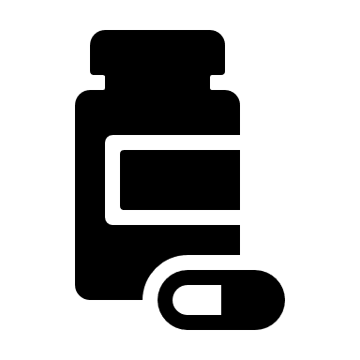

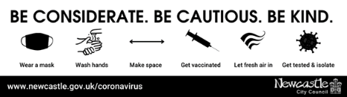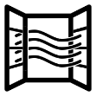

**Ventilation** – Opening windows and doors at home is the simplest way of improving ventilation. Ventilating your home does not mean that it has to be cold. Try to keep the temperature in the room at least 18ºC.

**At Home** – Observe strict social distancing and spend as little time as possible in shared spaces. Do not invite or allow social visitors to enter your home, including friends and family.

**Animals** – Check you have enough pet food & supplies. If required, ask someone else to look after your animal(s) during your isolation period.