Alcohol and Covid-19 Stay Healthy, Stay Safe
WORLD HEALTH ORGANIZATION WARNING!
DRINKING ALCOHOL WILL
NOT DESTROY COVID-19 AND
ITS CONSUMPTION IS LIKELY
TO INCREASE HEALTH RISKS IF YOU BECOME INFECTED.

THE FACTS: ALCOHOL AND COVID-19
According to the World Health Organization, alcohol use, especially heavy use, weakens the immune system and reduces the ability to cope with infectious diseases – including Covid-19.

CUT DOWN: KNOW YOUR UNITS
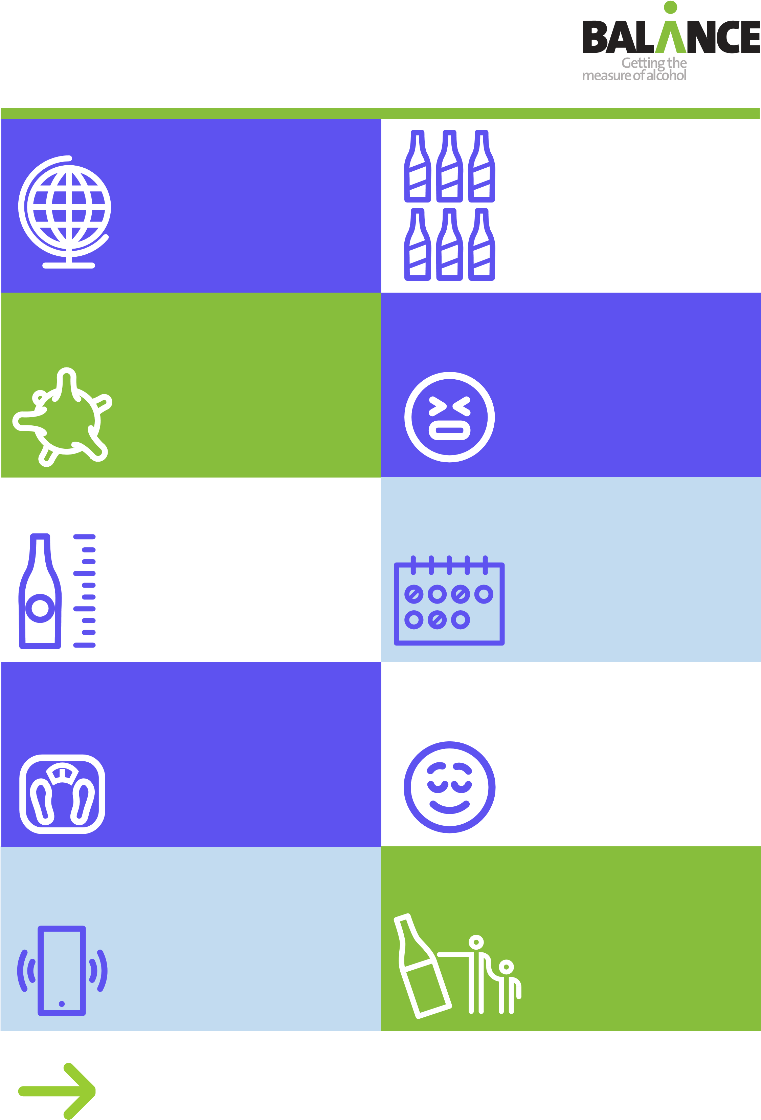
Chief Medical Officer advice is to drink no more than 14 units a week to stay ‘low risk’; that’s about six pints of standard strength beer or six medium (175ml) glasses of wine. An est. 650,000* people in the NE have cut down or stopped drinking during lockdown.
*Alcohol Change UK/Balance survey 2020
WATCHING YOUR WEIGHT?
You won’t see it on the label, but reducing your drinking can help stop you gaining weight. There’s 228 calories in a large glass of red wine (12% ABV) – about the same as a regular Mars Bar.

HELP IS THERE
If you or someone you love needs help or support with alcohol – speak up. The national alcohol helpline is 0300 123 1110.
.

Don’t stockpile alcohol in your home. Plan ahead, limit the amount you buy in and opt for non-alcoholic drinks to help you stay within the 14 unit low-risk weekly guidelines.
FEELING STRESSED OR ANXIOUS?
You might think alcohol helps you to deal with those feelings, but it’s not a good coping mechanism. Alcohol is known to increase feelings of anxiety, depression, stress and other mental health conditions.

HAVE DRINK-FREE DAYS
Taking at least three drink-free days every week is a great way to cut down on how much you’re drinking. The free Drink Free Days app will help you keep track.

RELAXING WITHOUT ALCOHOL
Top tips to help you unwind from Alcohol Change – read a good book or listen to an audiobook; have a long bath; go for a walk; exercise; try mindfulness and meditation.

ALCOHOL AND CHILDREN
Keep children and young people safe. Make sure they don’t have access to alcohol. And if you drink, try not to drink around them.
Visit www.reducemyrisk.tv for lots of helpful tips, advice and support to
keep your alcohol consumption down and reduce the risks to your health.

