October is the time for big benefit changes
Here are some significant benefit changes taking place from October 2013, a roundup of others and dealing with the impact of welfare reform.

Changes at a glance | Page
People with care and mobility needs …………………………………………  The change to Personal Independence Payment begins for existing Disability Living Allowance claimants | 1
Benefit appeal changes ………………………………………………………….  Extra stage brought in for those who want to appeal a benefit decision | 2
Universal Credit – no …………………………………………………………….  This major change is being rolled out but not in the North East | 3
Claimant commitment – yes …………………………………………………….  More work related requirements for jobseekers – with consequences | 3
Roundup of other changes ……………………………………………………...  News on the ‘cap’ the ‘under occupancy charge’ and discretionary help | 3
More details and help …………………………………………………………….  Including where to get advice and how Newcastle is responding to welfare reform | 4
Active inclusion Newcastle ……………………………………………………..  A short description | 4

The changes in more detail

People with care and mobility needs - Personal Independence Payment
This benefit is replacing Disability Living Allowance for those aged between 16 and 64. Already, people of that age have to claim PIP instead of DLA.

From 28th October, people getting Disability Living Allowance and aged 16 – 64, will be invited to claim PIP instead if:
- They report a change in their care or mobility needs, or
- A child on DLA is turning 16 (it is later for children classed as terminally ill), or
- An existing DLA award is due to end.

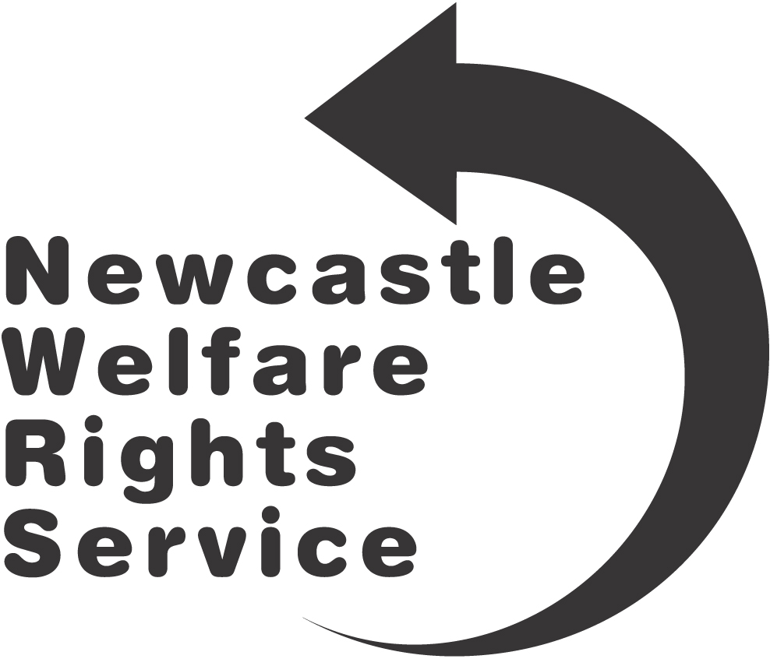
It is important to remember that there is no automatic transfer to PIP, it must be claimed.

The Government plan is that from October 2015 to 2017, the remaining people on DLA aged 16 – 64 will be told their DLA is coming to an end and will have to claim PIP instead.

More details from:
- Disability Rights UK:
www.disabilityrightsuk.org/personal-independence-payment-pip
- DWP: www.gov.uk/pip

Benefit appeal changes
If a person is unhappy with a benefit decision, they can appeal to the independent courts and tribunal Service.

This will change from 28th October. Instead, they will first have to ask the DWP to reconsider their decision. This is called a ‘mandatory reconsideration’. The DWP may phone to explain their decision. If the claimant is unhappy with that decision, they have one month (from the date of the DWP decision letter) to appeal directly to the courts and tribunal service, called a ‘direct lodgement’.

These new rules were already introduced for PIP and in Universal Credit areas. They will apply to all other DWP benefits and child maintenance cases. Appeal and dispute rules for Child Benefit or Tax Credits will continue as before.

The process in more detail:

- Written decision from DWP.
- Claimant has option of asking for an explanation.
- Claimant can ask for a ‘mandatory reconsideration’.
- DWP looks at their decision again.
- DWP rings claimant to explain and discuss decision.
- Claimant may submit further evidence now or later (the sooner the better).
- Claimant receives detailed mandatory reconsideration notice letter, including how to appeal.
- If a claimant is unhappy with this decision, they have one month to send in the form ‘SSCS1’ directly to the court and tribunal service.
- They must also enclose the DWP mandatory reconsideration letter.
- If the appeal contains further evidence the DWP will be asked to reconsider its decision.
- They can get the form ‘SSCS1’ form from the DWP, an advice agency or the tribunal service website: www.justice.gov.uk/forms/hmcts/sscs
- The tribunal service will write to the claimant. The claimant must reply.
- If the claimant chose to attend a hearing, s/he will be told of the date.

More details:
- From the DWP:
www.gov.uk/government/publications/appeals-process-changes-for-dwp-benefits-and-child-maintenance
- From Child Poverty Action Group:
www.cpag.org.uk/content/new-appeals-rules-and-procedures

Universal Credit – no!
Universal Credit is being rolled out to 6 Jobcentre Plus areas for new claims from unemployed single claimants. None in the North East.

Claimant commitment – yes!
The ‘claimant commitment’ was originally part of Universal Credit but it is being rolled out early from October 2013 across the country in Jobcentre Plus offices.

The Government say that “Jobseekers will have to account more clearly for their efforts to find work and will involve a weekly timetable of tasks to complete.” They will be expected to look for work for the same number of hours they are expected to work. This could be up to 35 hours, minus any hours of work related activity. There will be different requirements depending on which group they are in. Jobseekers for example, will have the highest level of work activity.

The claimant commitment is “backed by a strict compliance regime”. Those who fail to comply with this and other work related responsibilities “risk losing their benefit”.

This follows the increase of the sanction period of 2 to 26 weeks in October last year, from 4 weeks to 3 years.

More details from the DWP:
www.gov.uk/government/news/claimant-commitment-to-spell-out-what-jobseekers-must-do-in-return-for-benefits, and
https://www.gov.uk/government/uploads/system/uploads/attachment_data/file/209385/foi-2451-2013.pdf

Also see the recent report from Homeless link: http://homeless.org.uk/news/benefit-sanctions-hitting-homeless-people-hardest#.UkGpwHlwbGh

Roundup of other changes
The under occupancy charge (also known as the ‘bedroom tax’) continues to cause problems for many people. A recent legal challenge on disability discrimination grounds failed but is being appealed to the higher court.

Regular news can be found on the ‘inside housing’ website: www.insidehousing.co.uk/

In the meantime, the Government has given Local Authorities an extra £35 million towards their Discretionary Housing Payment funds. This is a time limited, discretionary fund for Housing Benefit claimants in financial hardship. It can be claimed from Revenue and Benefits:
Phone: 0191 278 7878. Email: benefits@newcastle.gov.uk
Website: www.newcastle.gov.uk/benefits-and-council-tax/benefits/discretionary-housing-payments

The household benefit cap has cut the Housing Benefit of 89 families in Newcastle. The average loss of income is £54 a week with the highest loss being £145 a week.

More details and help
Can be found on www.newcastle.gov.uk/welfarerights including where to get advice in Newcastle and benefit toolkits.

For information on the impact of welfare reform and what Newcastle City Council and partners are doing to try to mitigate it can be found in the recent Business Cabinet report which can be found at:
www.newcastle.gov.uk/your-council/councillors/meetings-agendas-and-minutes
Look for: 2013/cabinet/18September

Active Inclusion Newcastle

This benefit bulletin has been produced by Newcastle City Council’s Active Inclusion Unit, which is part of Active Inclusion Newcastle (AIN).

AIN is a delivery model that coordinates services that provide the foundations for stability by providing consistent information, advice and support that help people to secure:
- an income  - somewhere to live | - freedom from excessive debt  - employment opportunities

This is based on the Council and its partners working cooperatively to provide proportionate help to residents to sustain their independence through prevention services, emergency responses and targeted support to avoid repeat crisis. This means wherever possible proactively supporting people at life changing moments, rather than waiting for them to contact us in crisis. At the core of this are the following services and ways of working:

- Financial inclusion  - Crisis Support Scheme  - Supporting Independence Scheme  - Specialist advice  - housing  - debt  - welfare rights  - employment | - Statutory emergency accommodation  - Pathways and transitions  - Multiple exclusion  - Floating support  - Supported accommodation  - Debt collection  - Migration and asylum seeker support

For more details about the AIU phone 0191 277 1707 or email activeinclusion@newcastle.gov.uk

